LOHAN VADDEPALLY -150115236 – OSL840ZCC
Assignment 2: Installing WordPress in AWS (PaaS)

http://wordpress-env-1.eba-tuhibfp4.us-east-1.elasticbeanstalk.com/

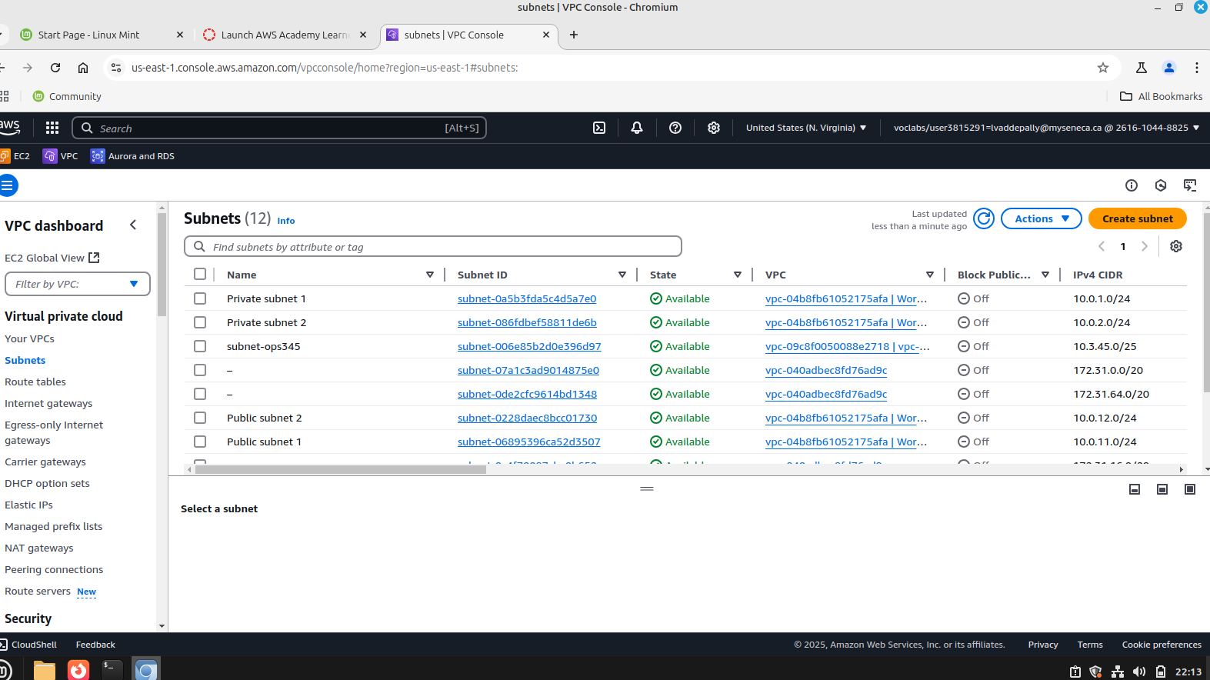
4 new subnets (Public Subnet 1, Public Subnet 2, Private Subnet 1 & Private Subnet 2)

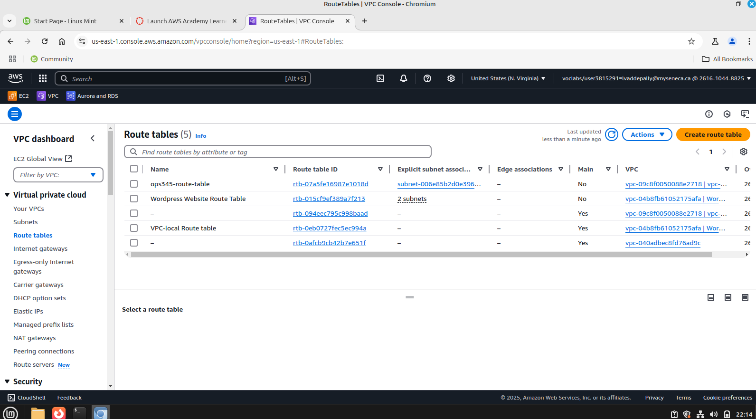
Route Table

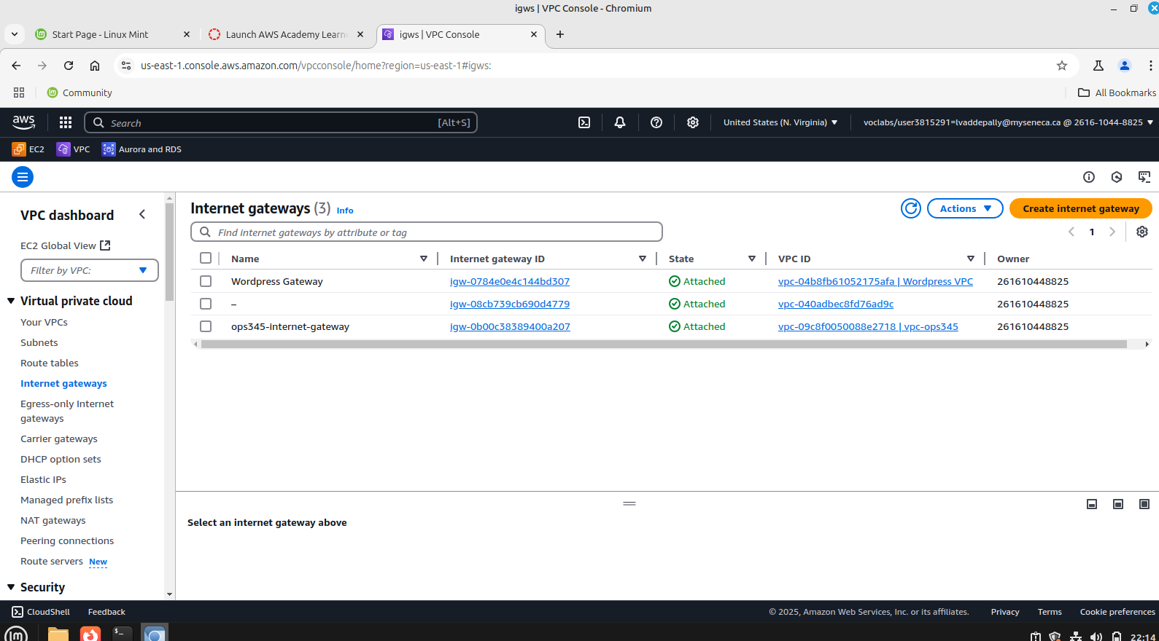
Internet Gateway
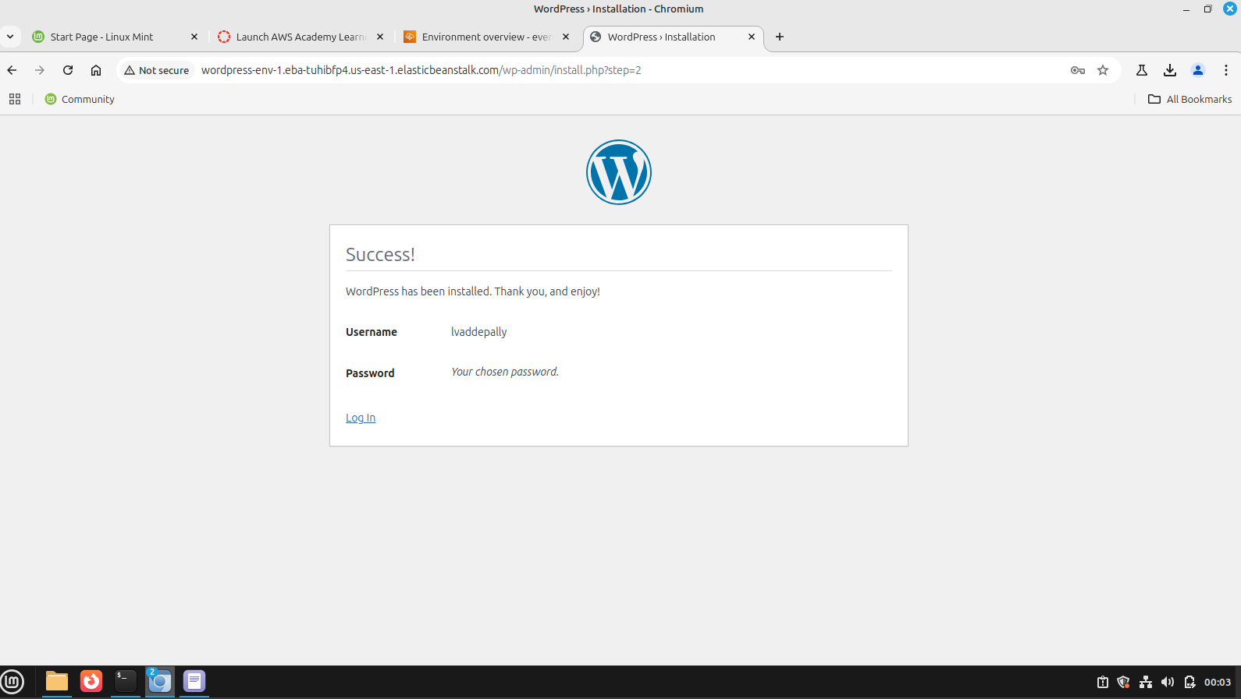

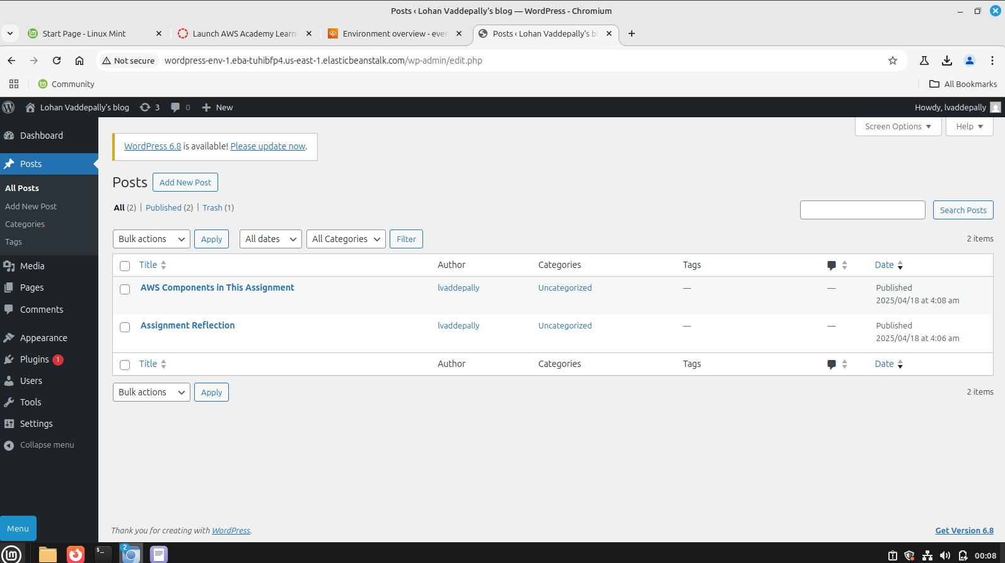
Wordpress blog

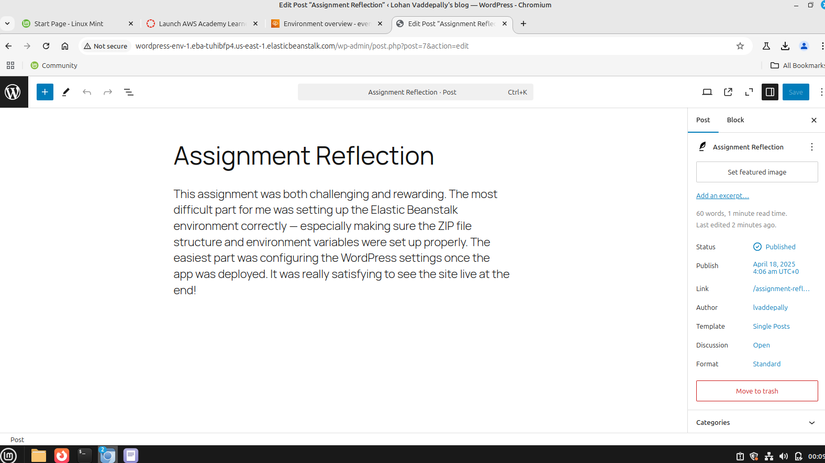
Blog Post 1

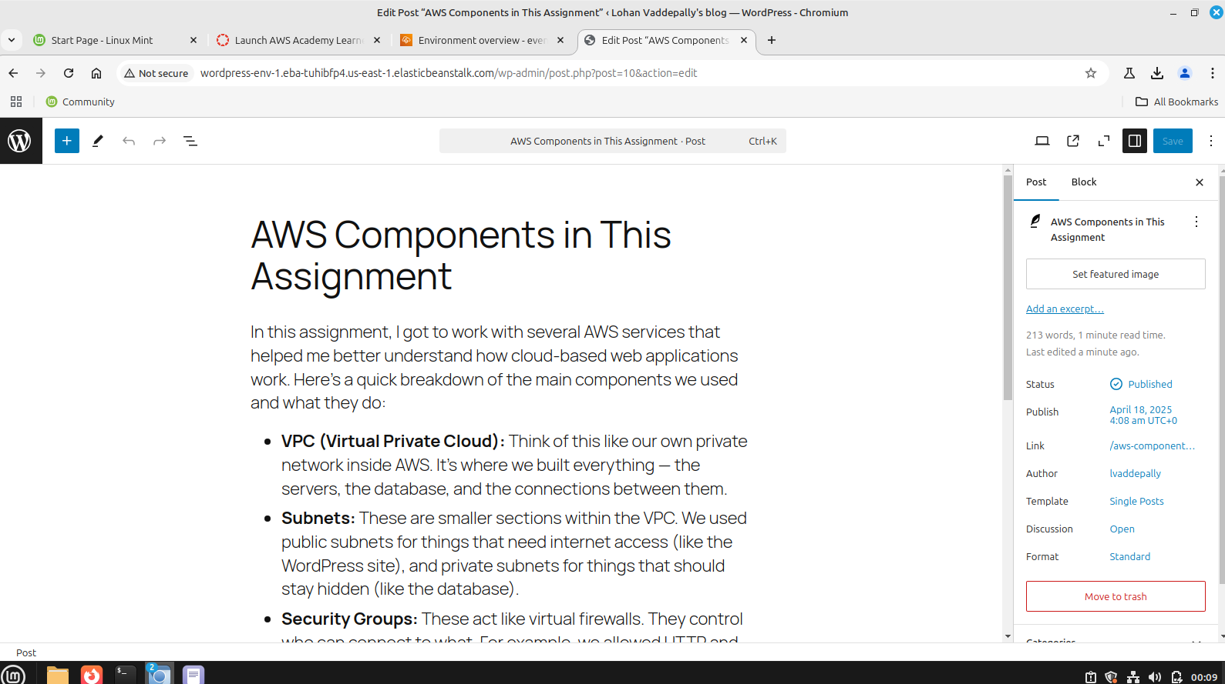
Blog Post 2

